**SPRINT-2**

|  |  |
| --- | --- |
| **PROJECT TILE** | Project – Nutrition Assistant Application |
| **TEAM ID** | PNT2022TMID08258 |

**Home page:**

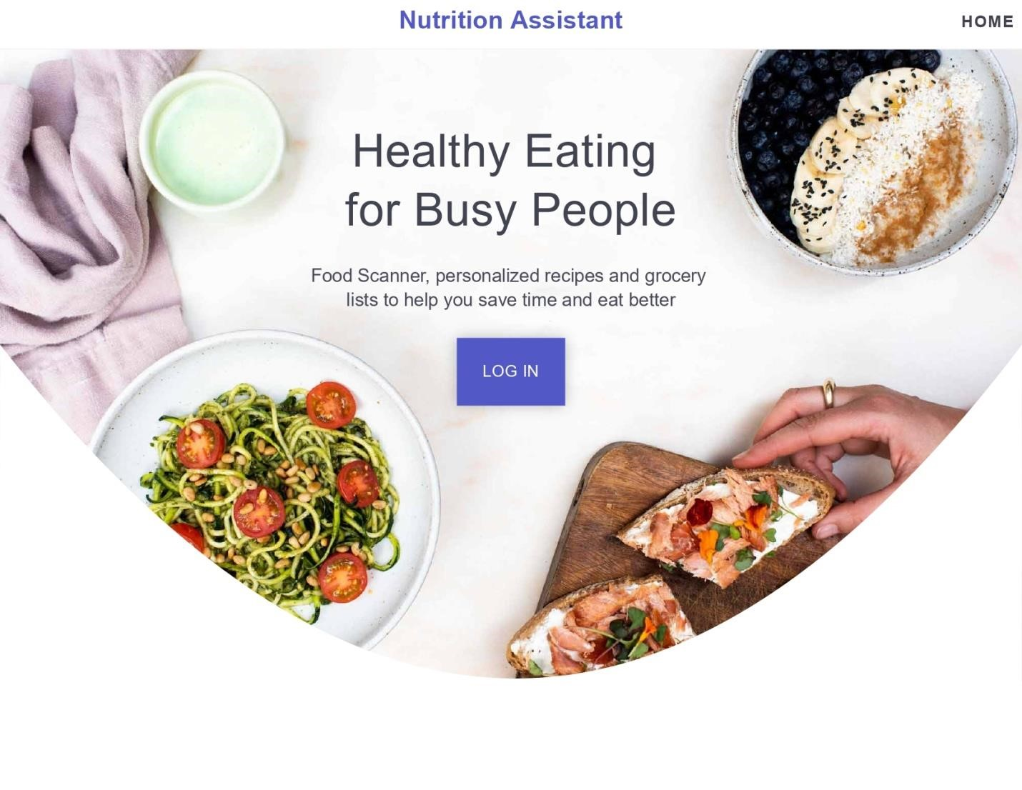

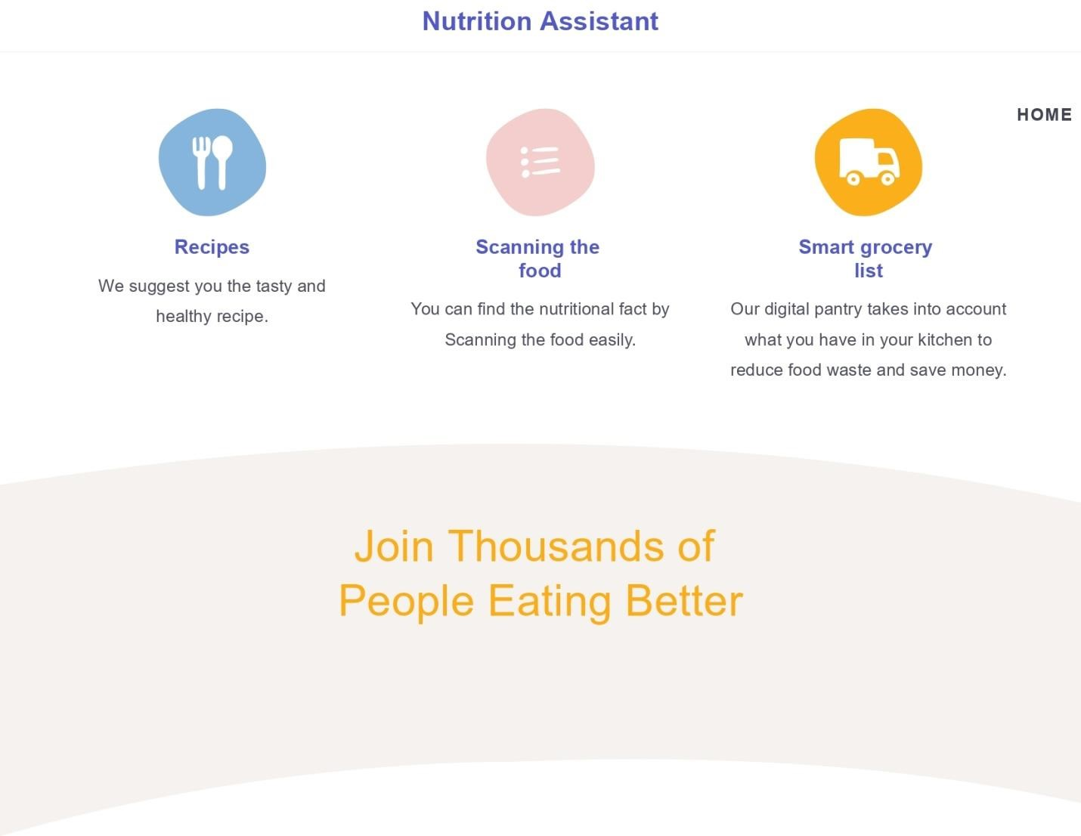

**Registration page:**

